UT-IT Test Report

UT 01 Product Owner Registration

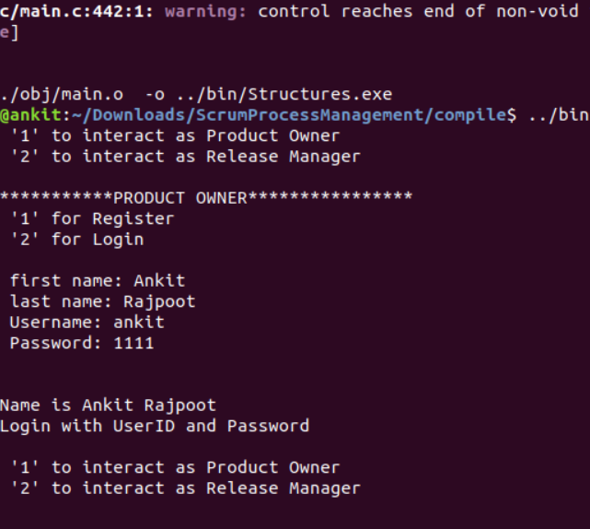

UT 02 Product Owner Login

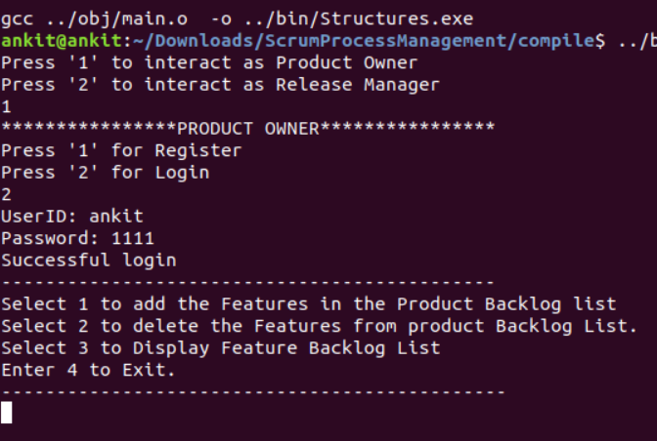

UT 03 Release Manager Registration

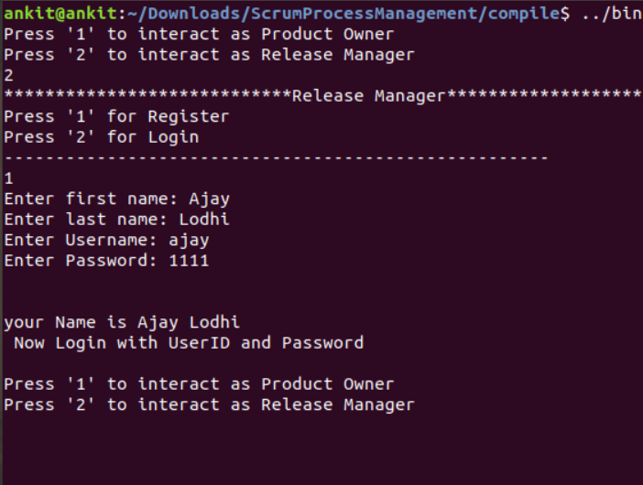

UT 04 Release Manager Login

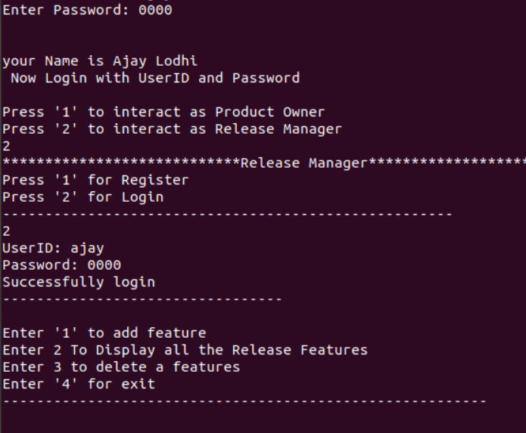

UT 05 Product Backlog Display

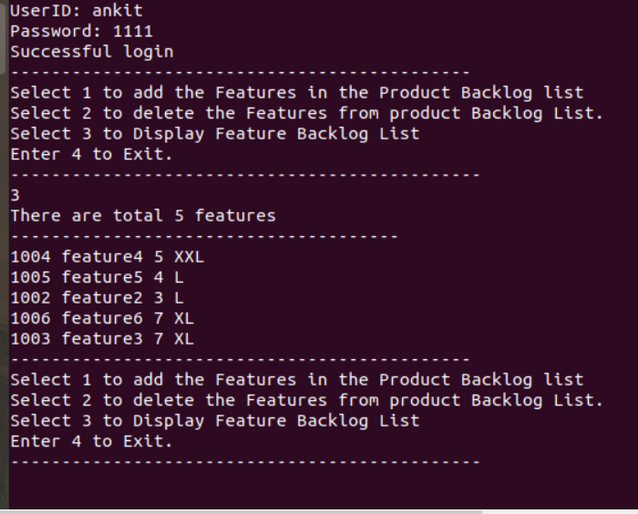

UT 06 Adding Product Backlog

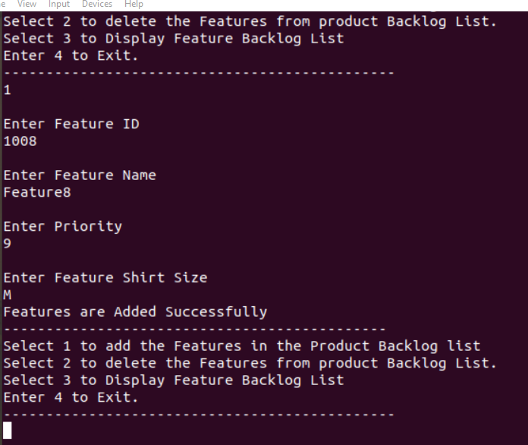

UT 07 Select Features from Backlog List

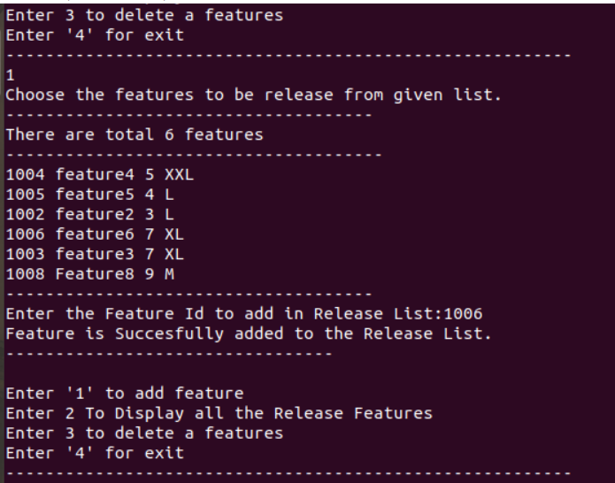

UT 08 Display Release Feature List

